TELEMEDICINE : A new horizon in public health
Tele-upchaar

By Vrinda Bhola, Lavanya Rathi and Sukriti Gupta

Aim & Acknowledgement
Introduction to telemedicine
Importance of telemedicine
Origin of telemedicine
Results of the survey we conducted
Our visits to Mathura
Telemedicine units in Mathura
Problems and probable improvements
Additional suggestions
Mobile Medical Units
Bibliography

AIM

To get a comprehensive understanding of the telemedicine system by:
- studying the idea behind it.
- Learning about the quantum of care provided within it.
- Making suggestions and providing probable solutions(if any) to the drawbacks of the system.

ACKNOWLEDGEMENT

We would like to express gratitude to all those who have helped us with this project. Firstly, we would like to thank Swami Kalikrishnananda ji for giving us this enriching opportunity because without him this project would not have been possible. He gave us the perfect platform to gain knowledge about telemedicine. We could also get a hands on experience of the functioning of the telemedicine units because of him. He gave us access to see the units in action for which we are eternally grateful.
Mr Nagesh Chaura, head of management of the telemedicine project, played an essential role in guiding us through the whole project. He made sure we got into the depths of the workings of the telemedicine units and mobile medical units. He personally made an effort and took us through the hospital and gave us an overview of the units. He also extended his extensive knowledge of research to help us with this project. He has been a mentor to us, who motivated us and kept us going.
The block coordinators also played an important role in helping us understand the procedure of the mobile medical units and telemedicine units.

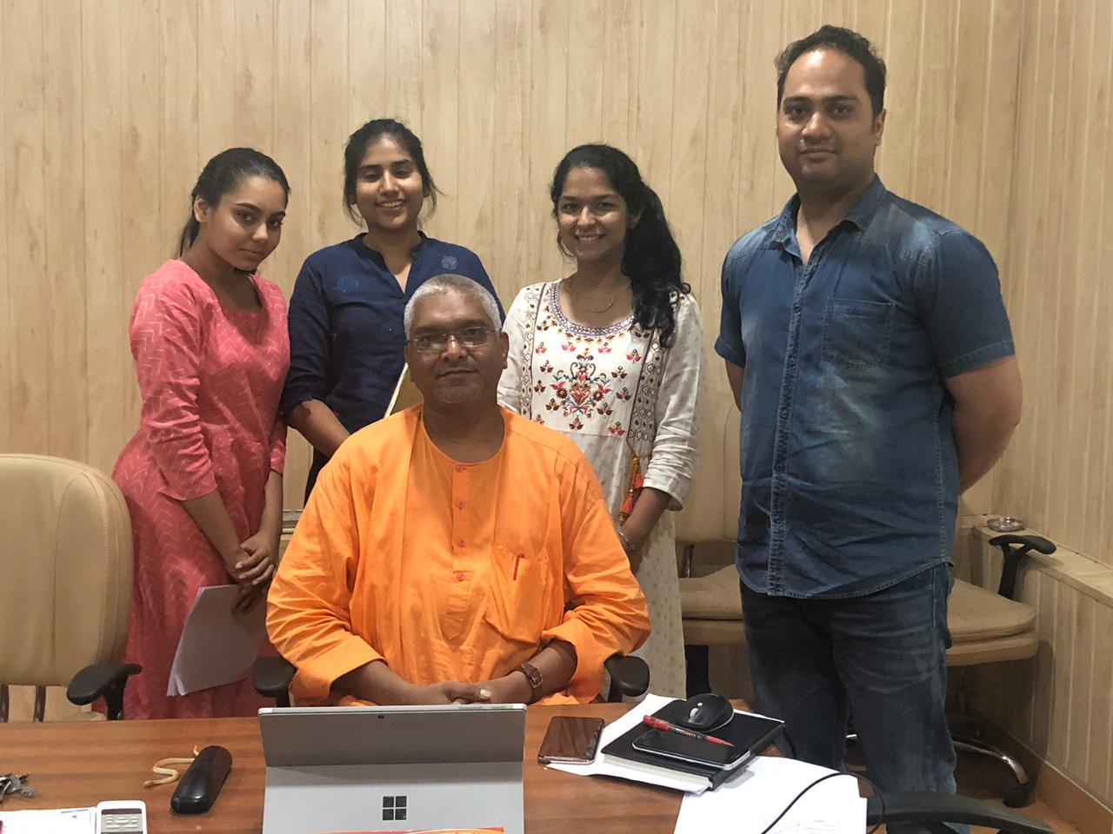
- Introduction to telemedicine
  - What is telemedicine?

“The delivery of healthcare services, where distance is a critical factor, by all healthcare professionals using information and communication technologies for the exchange of valid information for diagnosis, treatment and prevention of disease and injuries.”

The World Health Organization (WHO)
It was introduced in the interests of advancing the health of individuals and their communities. “Tele” is a Greek word meaning “distance “and “mederi” is a Latin word meaning “to heal”. Also, Time magazine called telemedicine “healing by wire”.

  - Importance of telemedicine

Although initially considered “futuristic” and “experimental,” telemedicine is today a reality and has come to stay. Telemedicine has a variety of applications in patient care, education, research, administration and public health. Worldwide, people living in rural and remote areas struggle to access timely, good-quality specialty medical care. Residents of these areas often have substandard access to specialty healthcare, primarily because specialist physicians are more likely to be located in areas of concentrated urban population. Telemedicine has the potential to bridge this distance and facilitate healthcare in these remote areas. This access not only allows people to speak with a doctor but also removes the expenses of traveling to a hospital. This is a great benefit for people in rural communities, where the nearest medical centre is 20-plus miles away, and for those who cannot, or are unable, to use public transportation . Telemedicine can also be used to check on patients and monitor them post discharge.

  - Origin of telemedicine

In 1940s Pennsylvania, radiological images were sent 24 miles between two townships via telephone line in the world’s first example of an electronic medical record transfer. Then, in 1959, the university of Nebraska established a two-way television setup to transmit information to medical students across campus, and five years later linked with a state hospital to perform video consultations ,thus becoming the first people to use video communication for medical purposes.
Telemedicine in India was formally launched on March 30th, 2000, when Bill Clinton— the then president of the United states— commissioned the first telemedicine unit in the village of Aragonda in Southern India, about 200 km from the tertiary care centre in Chennai. Since then, the Department of Information Technology (DIT) has started telemedicine projects in different parts of the country. As a prime organizer of telemedicine projects, DIT has undertaken major initiatives for the development of technology and standardization of telemedicine in the country. It has established more than 75 nodal centers all over the country to support research and development of telemedicine.

Since telemedicine is one of the unique applications of Space Technology for societal benefit, the Indian Space Research Organization (ISRO) has contributed significantly in its development. The ISRO Telemedicine programme started in 2001 has been connecting remote/rural/medical college hospitals and Mobile Units through the Indian satellites to major specialty hospitals in cities and towns. ISRO Telemedicine network covers various states/regions. Today, there are 175 telemedicine units in suburban and rural India and 15 in tertiary care hospitals.

Results of the survey we conducted
.

Our visits to Mathura

Background

In order to know more about telemedicine and its applications, we visited the Ramakrishna Mission Sevashrama hospital (RKMS) , Vrindavan which inaugurated 11 Telemedicine Units[TMU] and 2 Mobile Medical Units [MMU] with the name ‘Vivekananda Medical Service’. Out of the 11 Telemedicine Units, 9 were placed in nine different blocks of Mathura District and 2 are placed in the Vrindavan Hospital. This initiative was born out of the partnership between TATA TRUSTS MUMBAI and RKMS hospital in the Mathura district, wherein the TATA TRUST provides all the funds necessary to run this project. After understanding the working of the telemedicine unit in the hospital, we visited one of the telemedicine units situated in Karab(one of the blocks in the district) to understand its functioning . Conversation with the head of management, Mr. Nagesh Chaura was very informative and gave us an insight into this whole project. Also, talking to the patients, coordinators and doctors gave us a comprehensive idea of the project.

Objective of this outreach project

In the last 15 years, the population of India’s most populous state Uttar Pradesh increased by more than 25 per cent. However, the public health centres , which are the frontline of the government’s healthcare system, decreased by 8 per cent.
Smaller sub-centres, the first point of public contact, increased by no more than 2 per cent over the 25 years to 2015, a period when the population grew by more than 51 per cent.
This data, from the 2015 Rural Health Statistics, indicate how successive state governments have neglected affordable, accessible and quality healthcare for the 200 million people of the state, home to nearly a fifth of all Indians. Thus, the inefficient public healthcare system in Mathura, Uttar Pradesh led to the initiation of this philanthropic activity.
Under this project, more than 2.5 lakhs patients are expected to be benefited not just because it is a boon for their health but also because it is free of cost.
It mainly covers the following aspects:
- Faster Detection of Non-Communicable Diseases (NCD’s) like Cancer, Hypertension and Diabetes as compared to the conventional ways of detection.
- Provide Primary Healthcare near the doorsteps of the villagers
- Create Health Awareness
- Improve access to medical services by reducing the travelling time and cost.

TELEMEDICINE UNIT IN MATHURA
COVERING THE ENTIRE
MATHURA DISTRICT
Reaching Population: 26 lakhs
No. of patients to be treated: Approx. 3 lakhs
No. of villages covered: More than 700
No. of Blocks covered: All the 10 Blocks
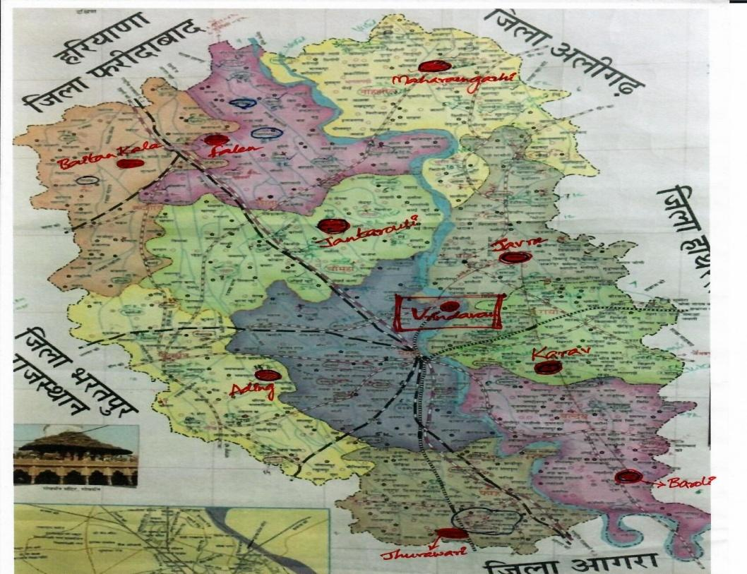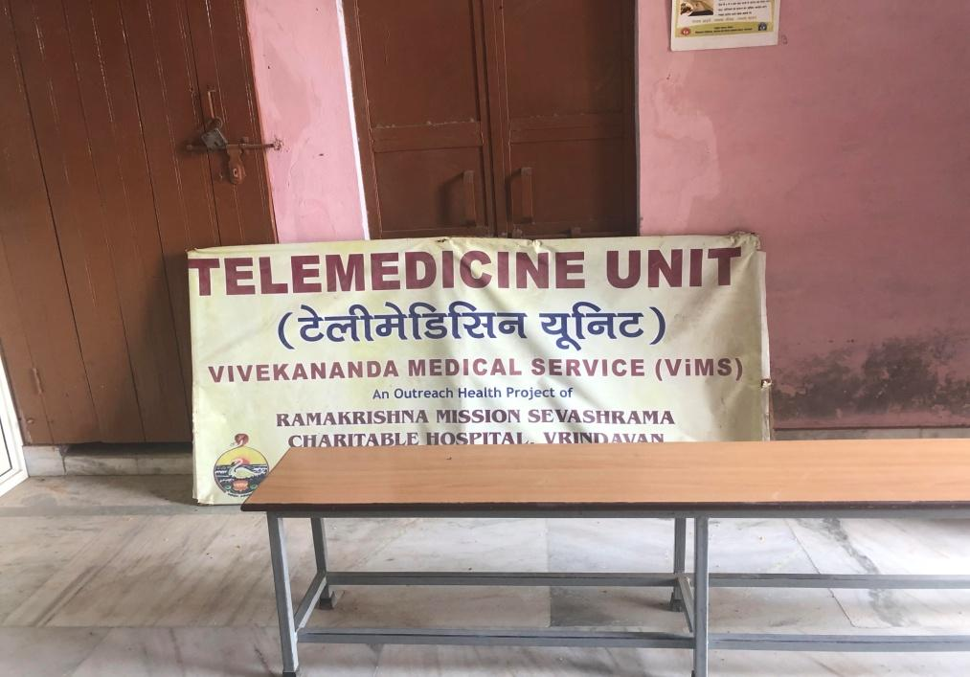
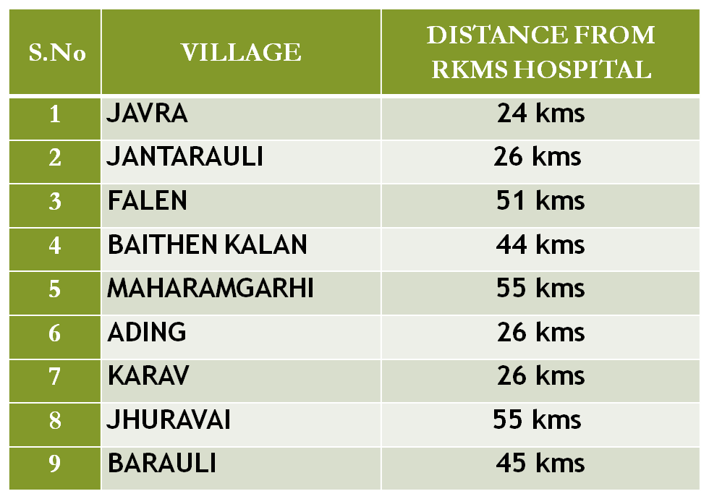

Human Resource
1. In the Ramakrishna mission Sevashrama hospital , there is a team of 3-4 doctors who are completely devoted to the patients in the village from 8:30am-4:30pmon all days except Wednesdays .Thus, they communicate with the patients using audiovisual means of communication and attend to 250-300 patients on a daily basis, each patient taking up around 3 minutes of consultation times.
2. To understand and convey the symptoms of the patient clearly to the doctor, a qualified male nurse is present. He is responsible for noting down the symptoms of the patient in a register and filling it up in the online database A unique ID is provided to every patient so that if a patient returns for a follow-up, the record of their previous visit can be instantly accessed. At the end of the day, the nurse has to make a daily report including the data of the patients and various medicines that have been prescribed to them.

3. There is an attendant as well who is responsible for maintaining hygiene and running errands. He is the one who mitigates the crowd especially during the peak morning hours. Also, no specific level of education is required for this task.
4. The block coordinators play an essential role and are responsible for managing all the activities in a block efficiently. Under their supervision and advice, different segments of telemedicine are linked in order to form a smooth functioning and beneficial system.
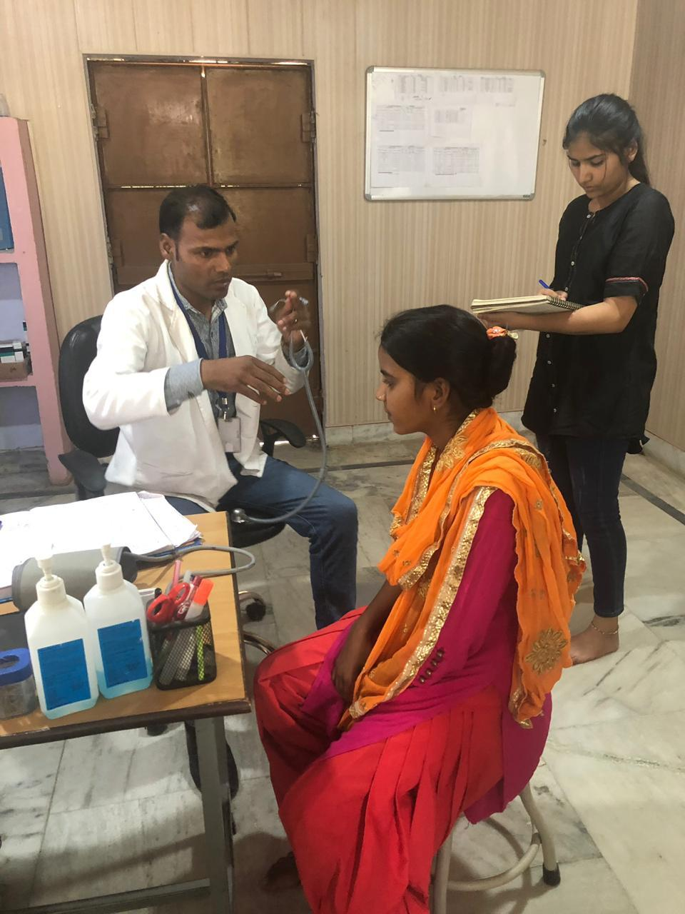
Infrastructure
The doctors carry out their work in a room [KNOWN AS HUB] equipped with computer screens (having an inbuilt camera for audiovisual communication), headphones and microphones.
The telemedicine unit in the village has a waiting area for the patients and a room equipped with the same communication technology as the one in the hospital. Medical equipment like a sphygmomanometer, weighing scale, glucose meter, stethoscope, makeshift stadiometer and a first aid kit is present here. The unit also has a stock of medical supplies which are given to the patient by the nurse only after consultation with the doctor. There are no provisions for emergency services as it aims to provide primary healthcare.

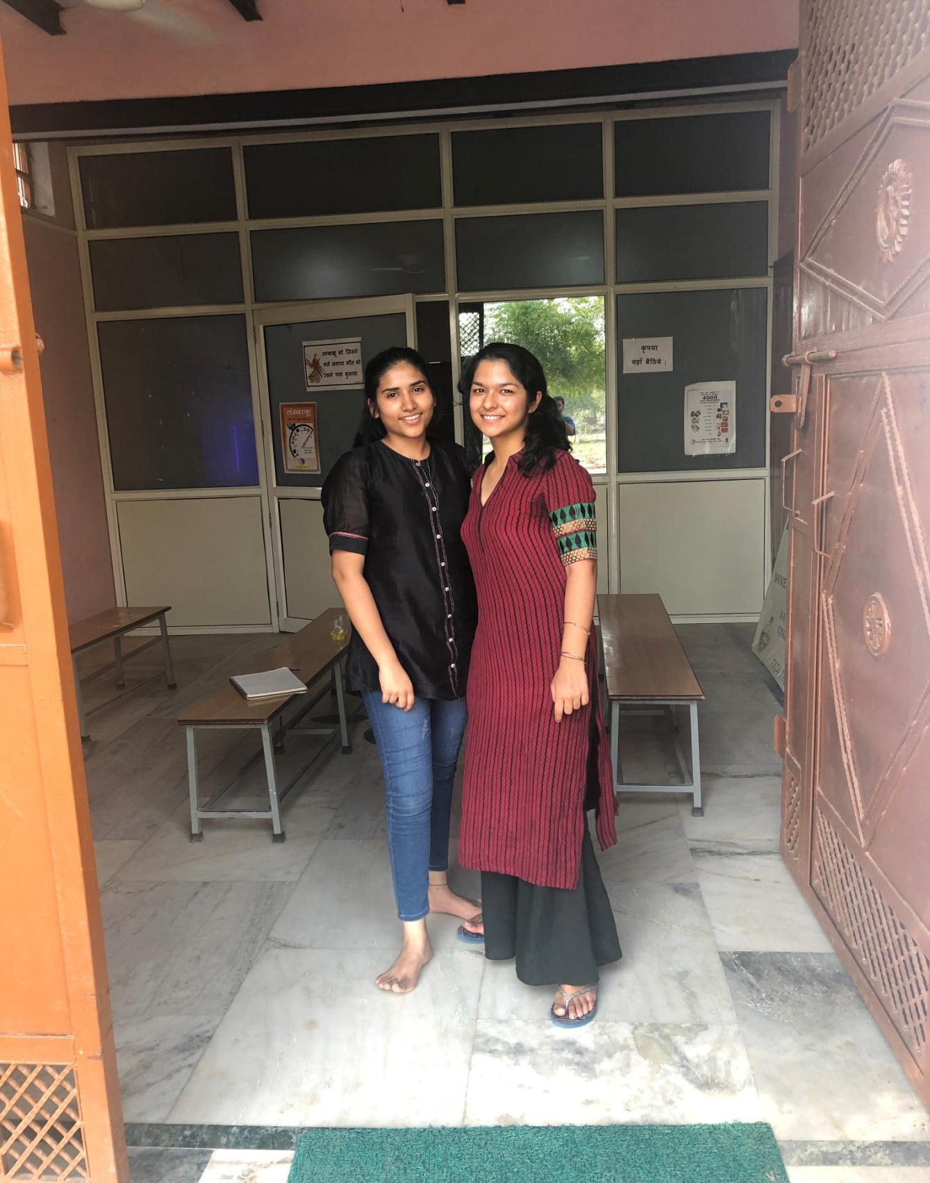

Doctor’s end
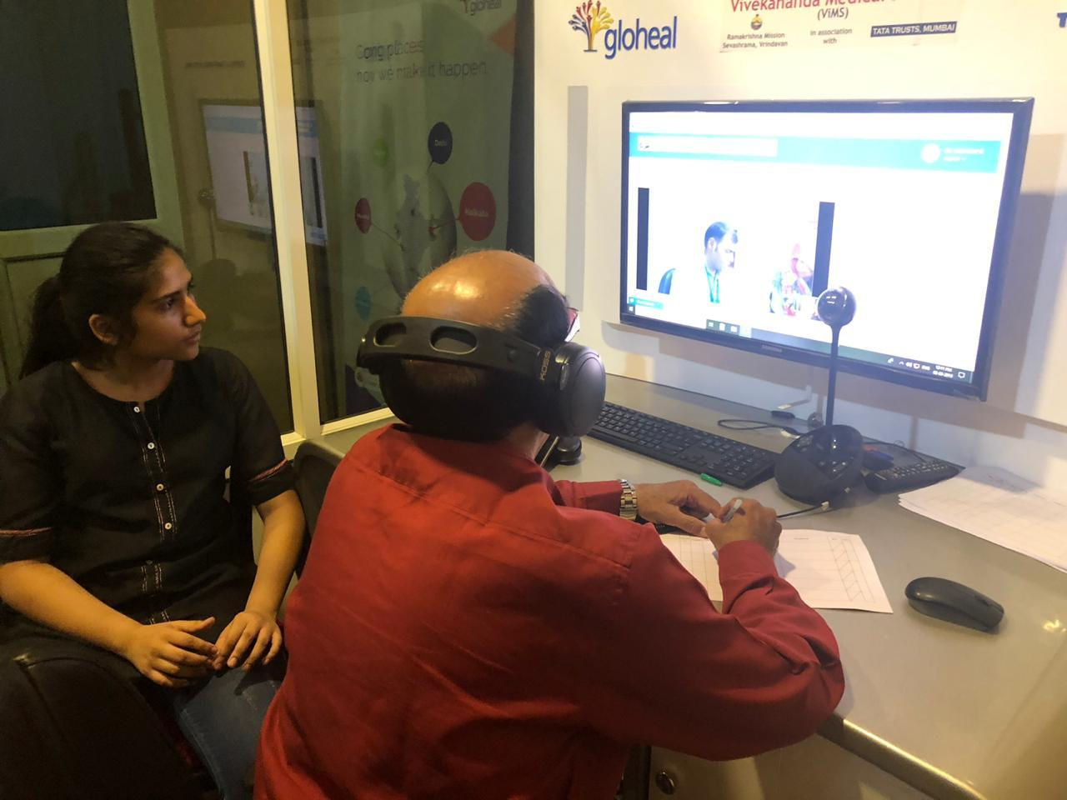

PROBLEMS AND PROBABLE IMPROVEMENTS
- CONNECTION
The telemedicine unit has connectivity problems from time to time. The link with the doctor is sometimes disrupted, leading to inconvenience for all: the patient, nurse and consultant. This disruption takes place usually during rainy season. The screen also hangs sometimes which leads to delays. In a system that is based purely on using satellite and communication technology, this is a grave issue. Sometimes it might take longer to connect to the doctor due to low internet speed or server problem .It is possible for the broadband connections to malfunction, video chatting gadgets to function improperly etc.

- PEST PROBLEM

There are small animals present in the unit like rats, squirrels etc which may cause diseases and contamination to the medical supply. Their droppings can give rise to the problem of pest control. Mice, rats and the parasites that come with them can carry a number of diseases and allergies, some of which are potentially deadly to humans, They’re known to eat just about anything. Their teeth can gnaw through insulation, wallboards, cardboard, even wood. Some are especially fond of electrical wiring and that can lead to real danger.

- BREAST CANCER
Early detection of cancer greatly increases the chances for successful treatment. Diagnosis of cancer generally increases the chances for successful treatment by focusing on detecting symptomatic patients as early as possible. Delays in accessing cancer care are common with late-stage presentation, particularly in lower resource settings and vulnerable populations. The consequences of delayed or inaccessible cancer care are lower likelihood of survival, greater morbidity of treatment and higher costs of care, resulting in avoidable deaths and disability from cancer. In the telemedicine units of Mathura, there is no device that can help in detection of breast cancer and many a time the symptoms go unnoticed ,thus in order to avoid this along with regular checkups female patients should also be asked to get a test for breast cancer.

Response to the problem

The process of detection of breast cancer is not undertaken in the telemedicine units because of unavailability of female staff. Women do not feel comfortable to talk about issues like these with male nurses. Female nurses are present in MMU and hence questionnaires regarding breast cancer are carried out there.

- Uneasiness and discomfort of the female patients in communicating their problems

The presence of a sole male nurse poses difficulties. The girls and women who visit to consult the doctor are hesitant and are not able to freely express their health issues. At times, the health problems are specific to women and the patients prefer a female nurse to attend to them. The reason why they have only male nurses is that the villages in which the units are situated are not safe for girls. Furthermore, the working environment is not conducive for women.

Response to the problem
Swami ji recognized this as a major problem and agreed with us that this needed looking into, but he also felt that there can be no possible solution to this problem as the safety of the female nurse in the units in the villages cannot be guaranteed. On the other hand, female nurses are present in the hospital and mobile medical units as these are considered to be safe for them. Thus, we came to the consensus that nothing can be done for this problem except that the female patients can visit the Mobile medical units for breast cancer detection instead of the telemedicine units.

- Lack of awareness among patients
After the patients have been treated for their respective ailments through the medicine they receive from the unit, they throw away the leftover medicine. This is because they lack awareness and knowledge of proper storage and conservation, thus leading to a huge wastage of resources that could be used efficiently.
Suggestion
We propose a ‘rules and regulations’ poster that will be put up on the wall of the telemedicine unit. It covers a wide variety of rules to be followed , including but not limited to returning the leftover medicine, the procedure to be followed for registration etc. It will make the functioning smoother and order will be maintained in the unit.

Response to the suggestion
Swami ji approved of our idea and really appreciated the effort that we made. He also made some changes in the sample poster we presented to him and has decided to put the poster in all 9 units.
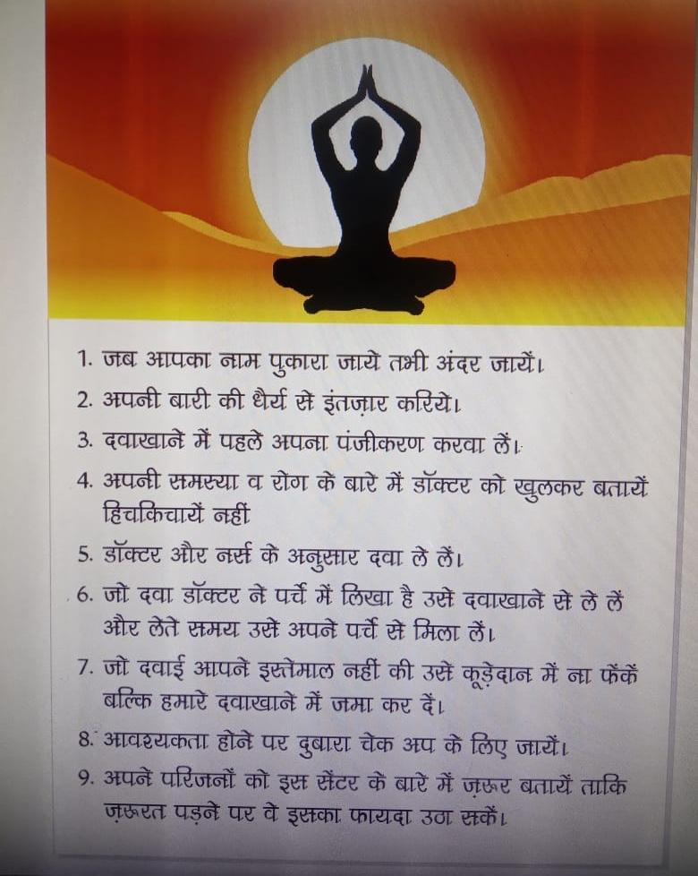

Additional suggestions
- It is essential for the patients to know basic healthcare tips. A constant reminder of healthy habits can improve the lifestyle of people. Therefore, we have put together a poster which includes all the necessary information regarding the same. It can be put up in the unit so that every patient who comes there can see these tips and implement them in his/her life. Swami ji was really open to this idea and he has decided to implement this poster in, all nine units with minor changes that he himself.

- Swami ji was appreciative of the innovative name that we came up with for our project that is TELE UPCHAAR.

- 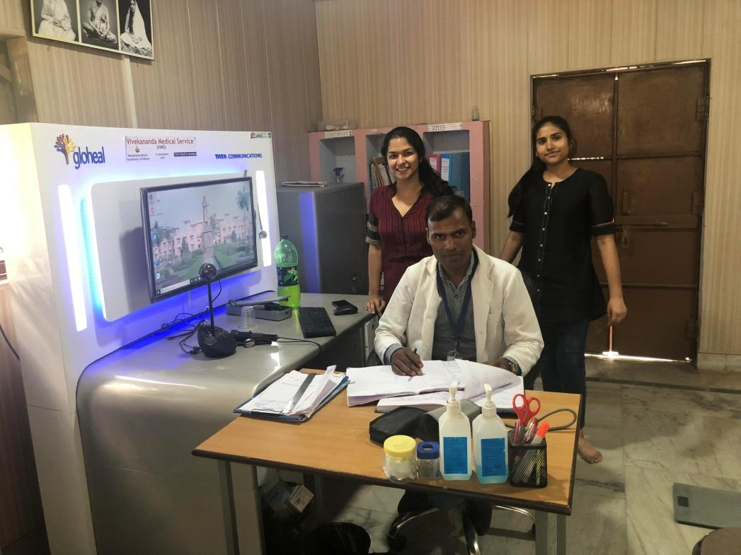

MOBILE MEDICAL UNITS (MMU)

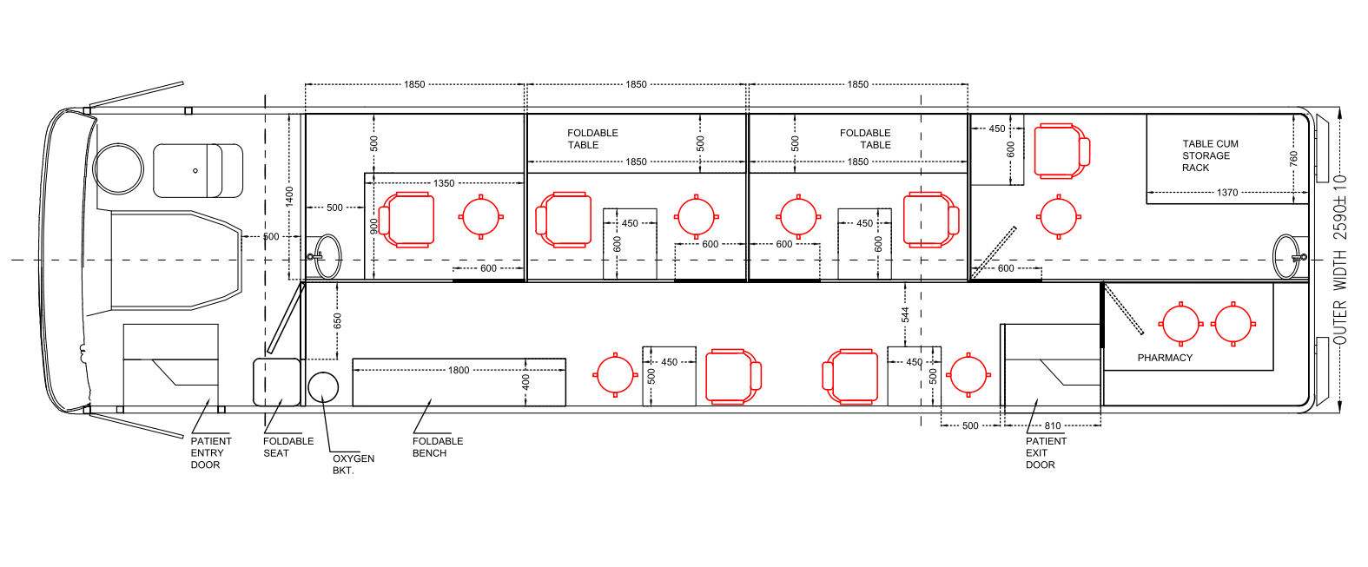

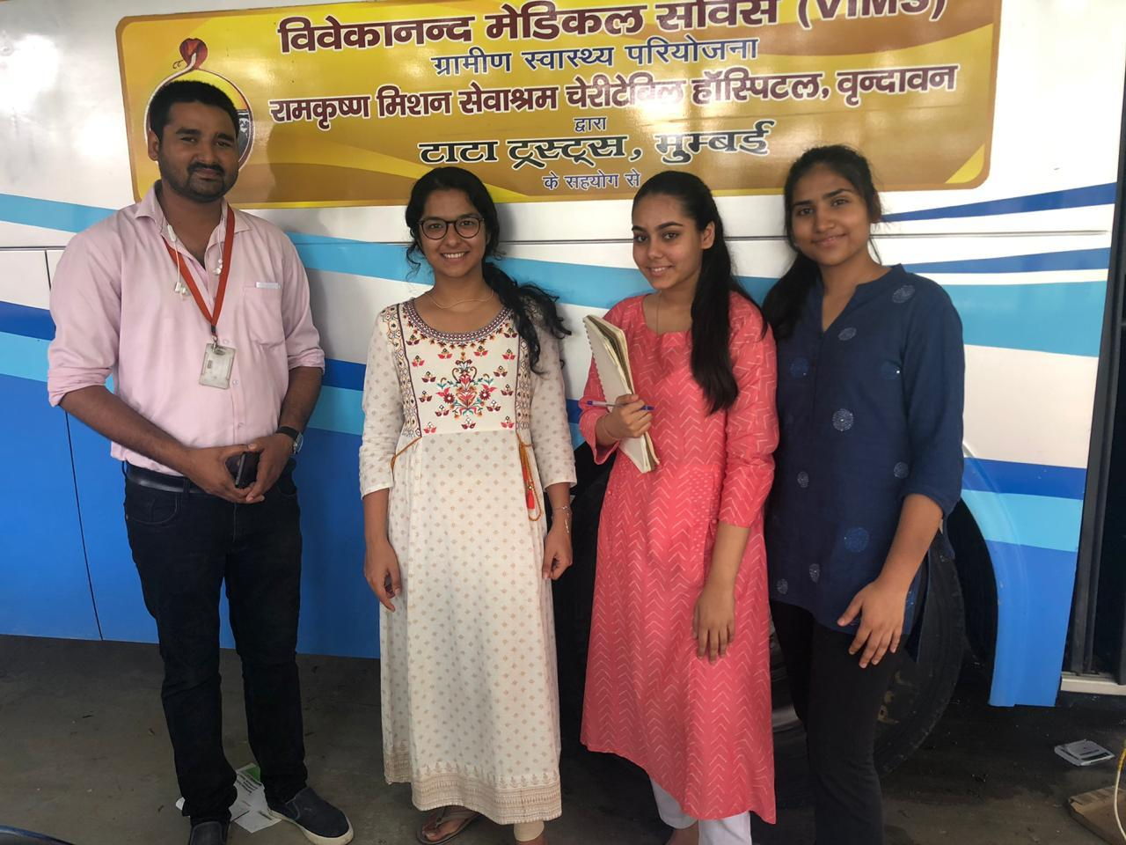

The MMU is a dispensary on wheels that offers a variety of prevention and healthcare services. The idea behind this initiative is to provide these services for populations living in remote, inaccessible and unserved areas mainly with the objective of taking healthcare service delivery to the doorsteps of the 2.5 lakh people there. 2 sophisticated MMUs run in various villages within the periphery of the Mathura district and these are located within a 3-5km radius of the aforementioned telemedicine units. The MMUs visit one block twice a month, covering all the 9 blocks of the district. The date and location of the MMU visit is discussed among the villagers at the community meetings conducted by the community health workers. Hence, not only are the date and location well known among the people but are actually decided according to their convenience and accordingly the schedule is fixed. The MMU is operational from 8:30 am-4:30 pm, on all days except Wednesday and Sunday. On Sunday, the medicine register is updated, the inventory is refilled and the bus is thoroughly cleaned. Everything, from consulting the doctor to blood tests and acquiring medicines from the MMU is free of cost.

INFRASTRUCTURE
- Entrance and Exit
As you enter the bus, a sitting/waiting area(patient couch) which can accommodate 4-5 people is visible on the right (the rest of the people wait in a line outside the bus ). After the consultancy is completed, the patients go out from the exit on the other side of the bus. This maintains a consistent flow of the people.

2. Eye OPD (Out Patient Department)
Opposite the waiting area is the eye OPD with equipment screening for blindness, refractive errors and other common eye problems like hypermetropia , myopia, presbyopia and conjunctivitis. Also, it takes around 5-7 minutes to conduct the vision test. The eye OPD includes:
- A fundus camera which is a specialized low power microscope with an attached camera that allows the doctor to closely examine the eye. This instrument is used to view structures of the eye such as the cornea, iris, and lens.
- There is an electronic screen which displays the Snellen eye chart to check the acuity of vision.
- It also has a vision box with lenses which is used to carry out the vision test.

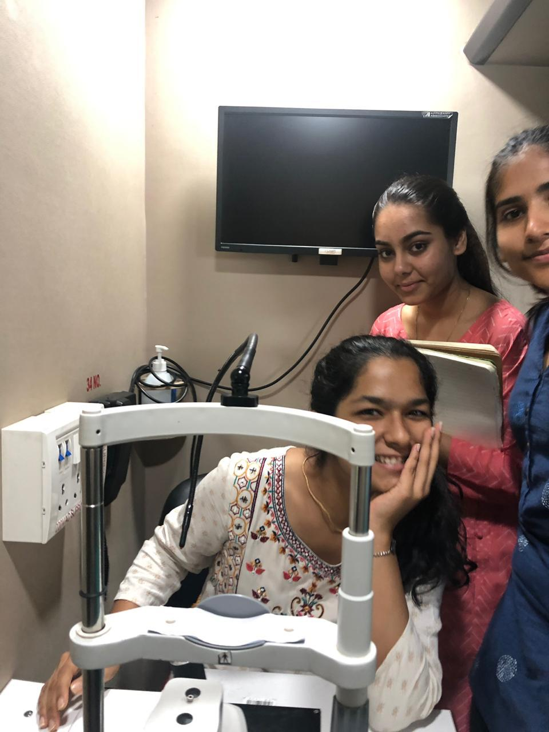
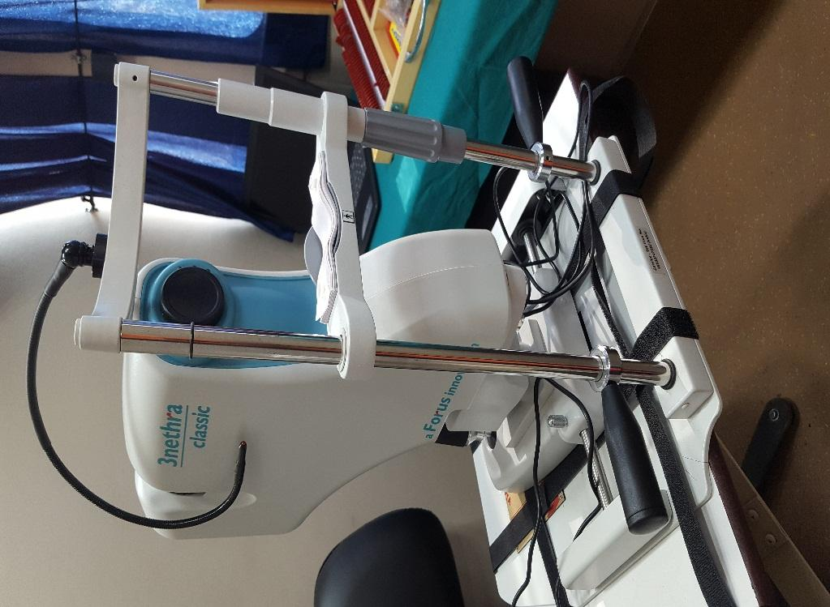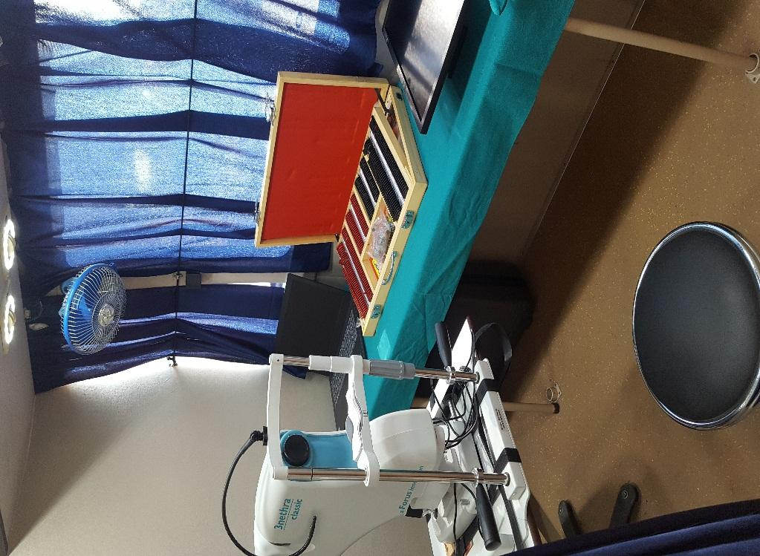

3. General OPD
Next to this is the general OPD which has equipment for screening non-communicable diseases such as diabetes and hypertension. This includes:
- A Sphygmomanometer which is an instrument for measuring blood pressure, typically consisting of an inflatable rubber cuff which is applied to the arm and connected to a column of mercury next to a graduated scale, enabling the determination of systolic and diastolic blood pressure by increasing and gradually releasing the pressure in the cuff.
- A glucose meter which is a medical device for determining the approximate concentration of glucose in the blood.
- A Stethoscope which is a medical instrument for listening to the action of someone's heart or breathing, typically having a small disc-shaped resonator that is placed against the chest, and two tubes connected to earpieces. 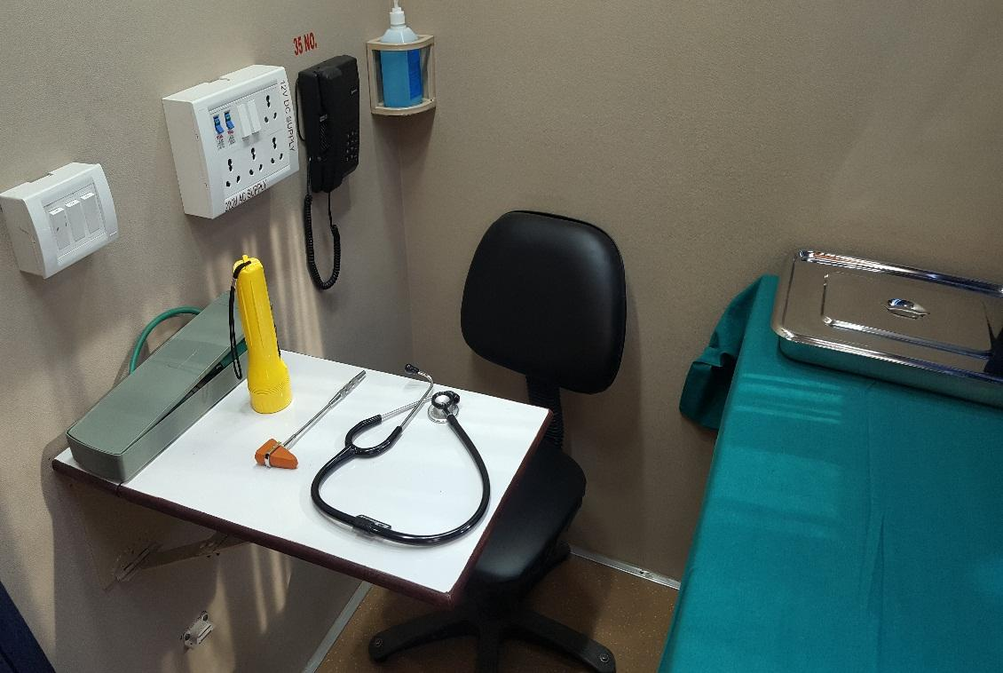
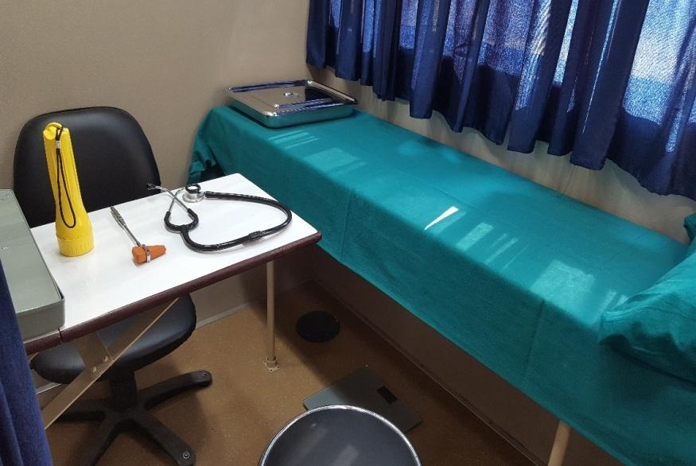
4. LABORATORY
There is a laboratory next to the general OPD where 72 types of tests (of the blood sample) are conducted including malaria, dengue etc. The results of the test are available in 15-20 minutes.

EQUIPMENT IN THE LABORATORY
- Microscope with Slides- A microscope slide is a thin flat piece of glass, used to hold objects for examination under a microscope.

- Serology Kits include equipment for Serologic tests which are blood tests that look for antibodies in the blood. Different types of serologic tests are used to diagnose various disease conditions

- PC Based ECG ( electrocardiograph) – it improves accuracy, enables immediate access to patient diagnostic information and enhances the practice’s efficiency. It automatically transfers patient information and test data into most electronic medical record (EMRs) without redundant work steps, misidentified patients, or delays from copying, scanning and shredding ECG reports.

- Analyzer-USB port- USB analyzer is an easy to use software-based for Windows, which provides a complete yet simple to understand view for monitoring and analyzing.

- Centrifuge- A centrifuge is a laboratory device that is used for the separation of fluids, gas or liquid, based on density. Separation is achieved by spinning a vessel containing material at high speed; the centrifugal force pushes heavier materials to the outside of the vessel.

- Power Backup (Designed for at least 4 hours backup)

- Incubator- The incubator maintains optimal temperature, humidity and other conditions such as the Carbon dioxide (CO₂) and oxygen content of the atmosphere inside.

- cuvette -A cuvette (French: cuvette = "little vessel") is a small tube-like container with straight sides and a circular or square cross section. It is sealed at one end, and made of a clear, transparent material such as plastic, glass, or fused quartz.

ADDITIONAL PROVISIONS OF THE LAB:
a) KFT (Kidney Function Test) which includes Urea /Uric
Acid/Creatinine

b) LFT (Liver Function Test) which includes Albumin/Total Bilirubin

c) Lipid Profile which includes Cholesterol, HDL / Triglycerides

d) Blood Glucose, Hemoglobin test

e) Mini Laptop /Data Recorder is present

f) Portable Cold Storage Unit

g) Portable BMI, BP machine, Urology Kit, Thermometer
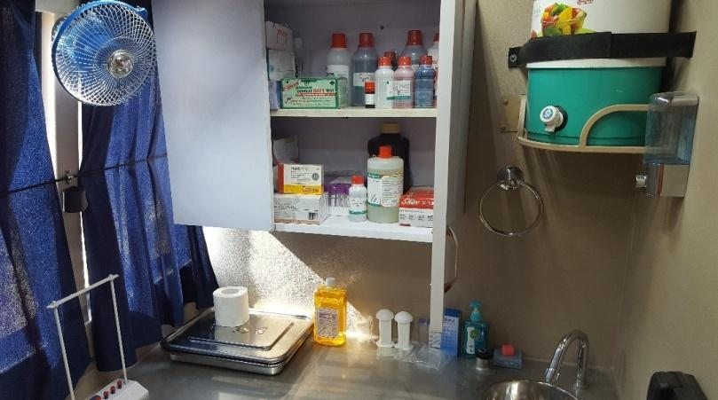
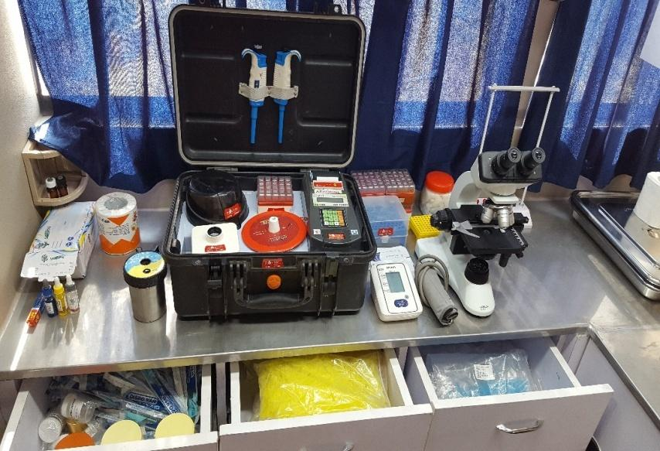

5.CANCER OPD
Finally next to this is the cancer OPD (diagnosis of three types of cancers only: 1.oral cancer 2. Breast cancer 3. Cervical cancer) where screening is done through making the patients answer a detailed questionnaire. A colposcope is also used for screening cervical cancer. It lets the doctor or nurse get a close-up look at the cervix — the opening to the uterus. It is used to find abnormal cells in the cervix. The room also has a doctor’s desk.
Patients who are 30+ years and are availing the services of MMU for the first time are screened for cancer. Every visit, at least 100 patients are screened out of which 5-6 are usually suspected for cancer. Those who are suspected are sent to the hospital for further detection and treatment. Due to a general fear and stigma of cancer in the villages, the patients are not informed that the questionnaire is for detecting a disease like cancer.
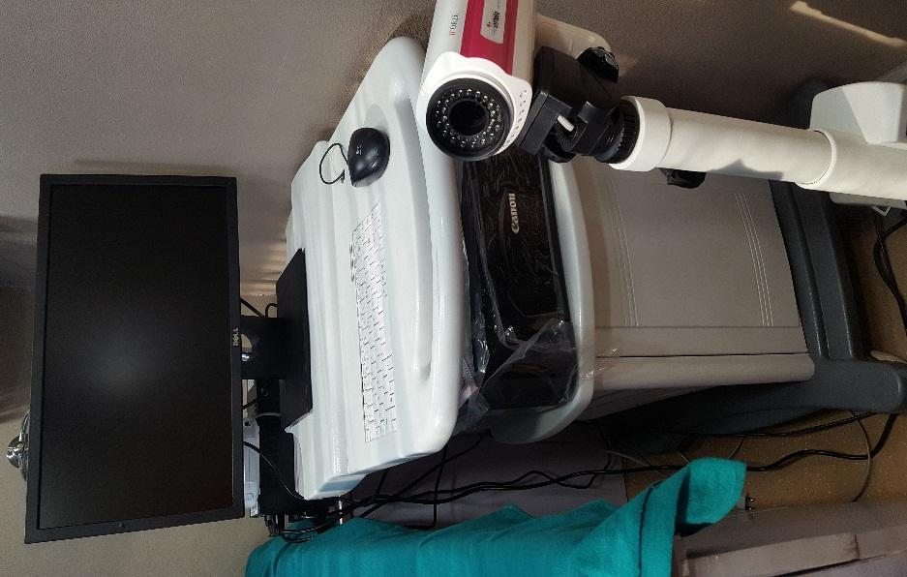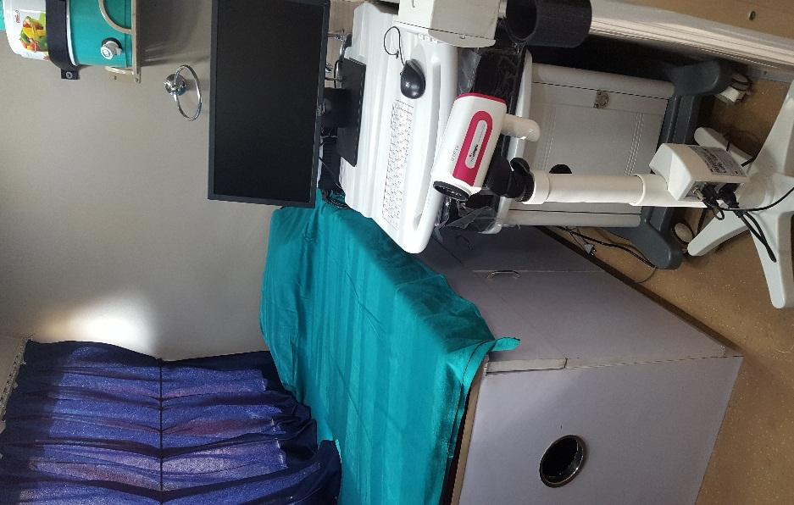
6. OTHER INFRASTRUCTURE
- In the aisle of the bus, there is a doctor’s desk where he/she sits and consults for common ailments like cold, cough, influenza, fever etc.

- Patient counseling desk is next to the doctor’s desk and this is where the patient goes if he/she wants any information regarding his/her diagnosis or further treatment.
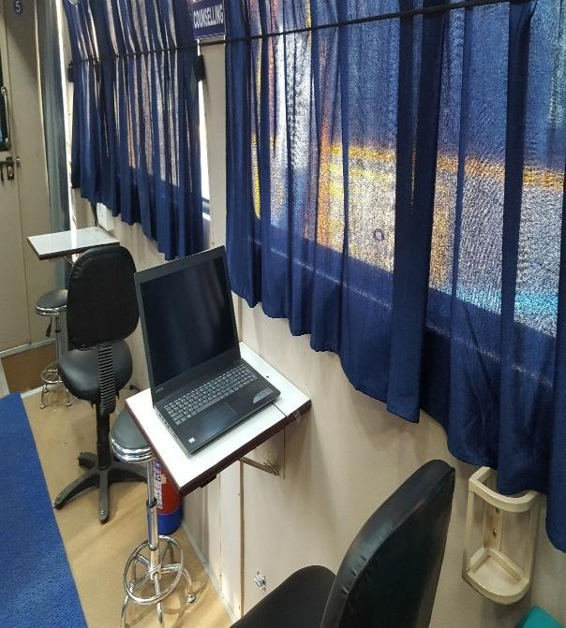
7. PHARMACY
There is a pharmacy where all the medicines are stored in the storage cabinets and drawers. The stock present in the MMU is nearly twice the medical stock in the TMU although the type of medicines are the more or less the same. There are 81 medicines in the pharmacy. The medicines are handed over from the medicine dispensing counter.
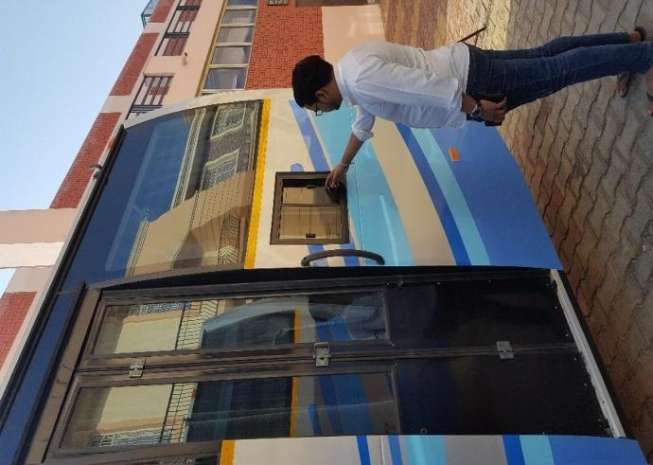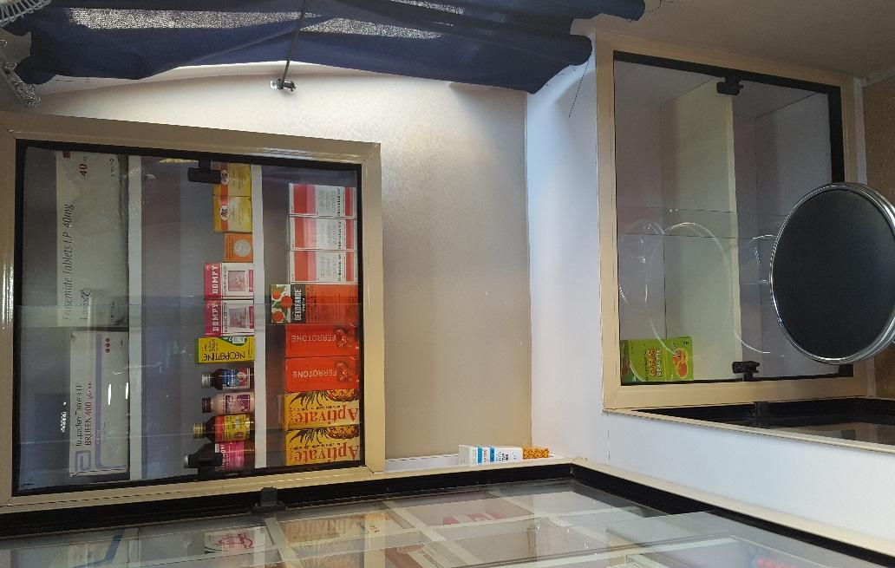

Each room mentioned above comprises of an examination couch.
All the equipment is secured in a box till the time the bus reaches its target location considering the fragility of the apparatus and moving nature of the vehicle.

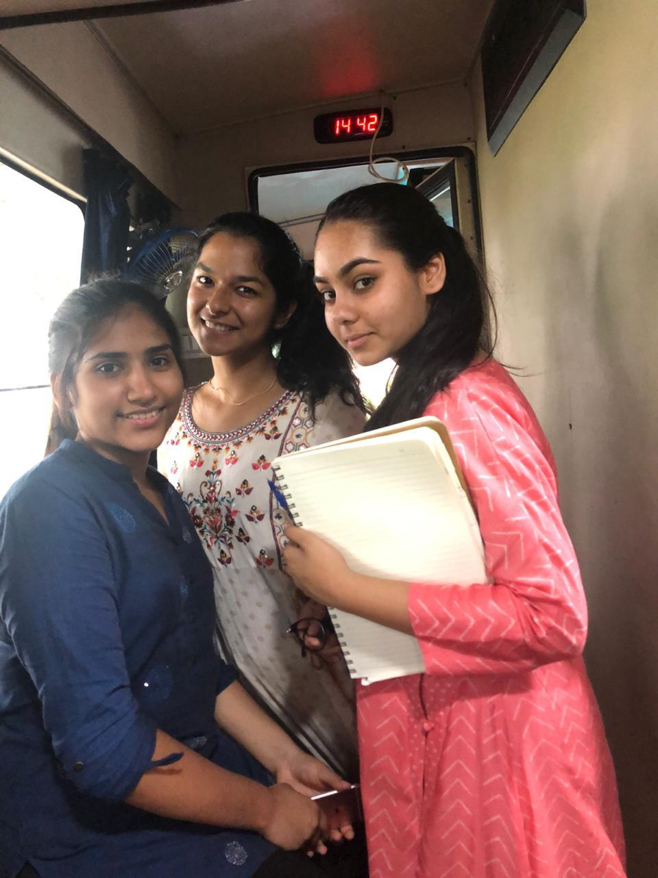

Human Resource
- Medical Officer (MO) /Doctor)
a) Mo will be the in-charge and overall responsible for consulting the patients. In one MMU ,two doctors are present. The other staff of the MMU provides assistance and work under his supervision
b) Mo is from the Ramkrishna mission Sevashrama hospital and works with the telemedicine patients as well.
c) enables easy access of referral services in emergency cases.

- Nurse(generally female)
a) to assist the Mo of the MMU in providing the health care services.
b) as they are qualified, they sometimes counsel the patients in distress and explain the details of the patient’s disease.
c) they conduct questionnaires for female patients suspected with breast cancer.

- Pharmacist
a) 2 pharmacists are present in the MMU and their job is to dispense the medicines to the patients prescribed by the Mo.
b) to maintain all adequate stock, inventory and issue registers.
- Laboratory Technician
a) to carry out the diagnostic tests/laboratory tests as per the requirement and feasibility.
- Optometrist
    - To conduct the eye exam for the patients in need.

5. Role of community health workers
a) Generate awareness regarding the availability of MMU, service provided, frequency of visit and schedule of MMU.
b) Mobilization through home visits and community meetings
c) identify Community groups /patients who would particularly benefit from the services of MMU.

6. Block coordinators
They are responsible for the management and proper functioning of MMU. They accompany the MMU to their allocated blocks and make sure the activities on the field are carried out efficiently. As and when required, they take part in patient counseling as well.

Additional arrangements in MMU

1..Primary Screening Desks outside the MMU Vehicle.

- Projector with Screen to display the Health Education
Videos.

- Awning facility on both sides of the vehicle to protect
from heat.

- Generator and inverter for uninterrupted power supply.
- Fully air-conditioned for the safe upkeep of medical
equipment and comfort of the patients & staff.

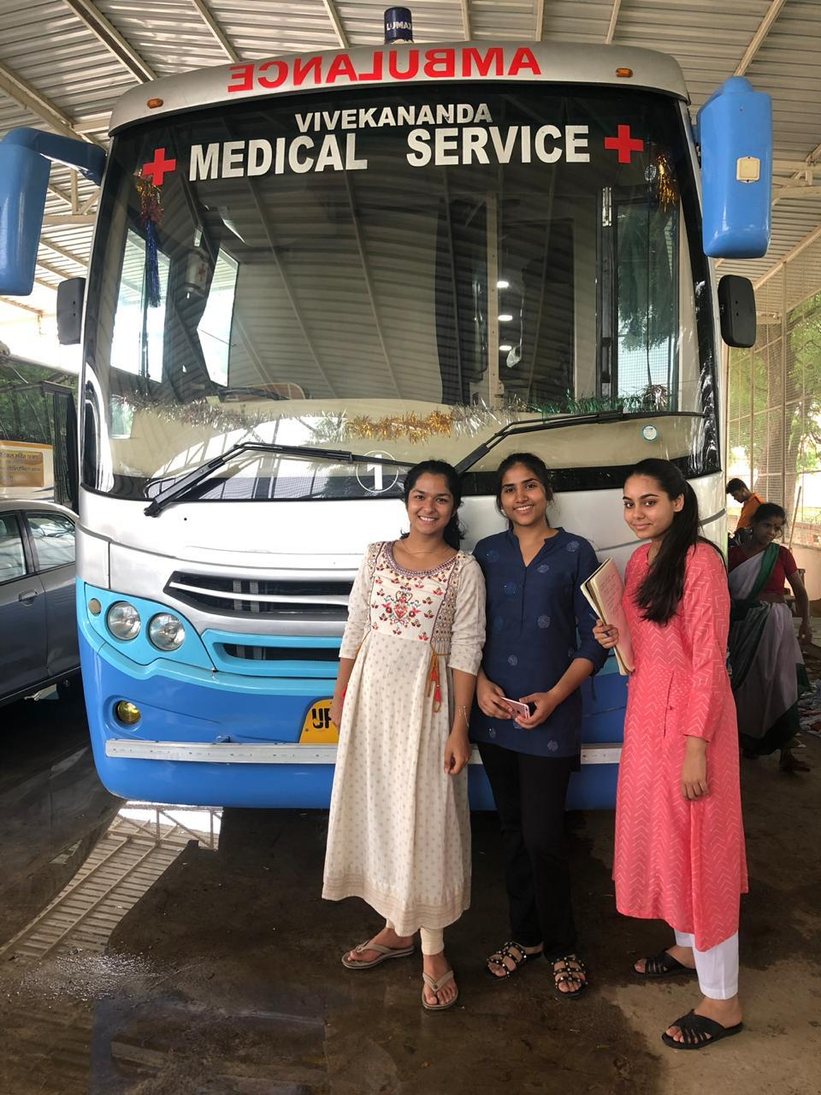

BIBLIOGRAPHY

Nearly 70% of the data presented in the draft is primary data because we gathered most of the information from observing the working of the telemedicine and mobile medical systems in Mathura. We acquired it through our experiences, interviews and surveys. Discussions with patient , doctors, nurses, block co-coordinators, Swami Kalikrishnananda ji and Mr. Nagesh Chaura have contributed significantly to our project.
Other sources are:
1.Rxdx.in
2.Eztalks.com
3.Who.int
4.Florida pest control and chemical co.
5.Everylifecounts.ndtv.com
6.Wikipedia
7.Swami kalikrishnanda ji’s personal presentation that he presented during the inauguration of mmu
8.Laboratory centrifuges
9.Biocompare.com
10.USBlyzer.com
11.Britannica.com
12.Healthline.com
13.Welchallyn.com
14.Nhsrc.org
15.www.isro.gov.in

